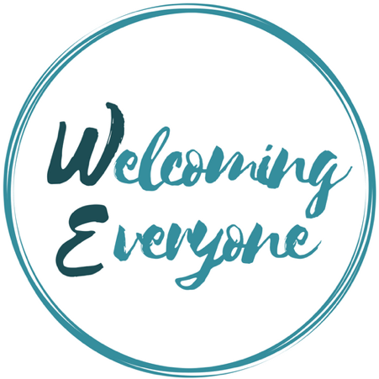

Many Stories, One Community
May 3rd, 2020
6:00 to 8:30 PM
Sewickley Public Library

Guidelines for Submitting a Story

Why: Every community is like a library where residents, each having different life stories, live side-by-side like books and DVDs on the shelves. Those stories often remain hidden under "covers" until they are "opened" through sharing them.

Theme: Please tell us about a person who or event that changed the way you think. While the story should be true, please use descriptive language and let your creativity flow! Each story should have a conflict and a resolution.

Length: It should be no more than 650 words that can be read aloud in 5 minutes or less.

Deadline: Stories must be submitted by 5 PM on Sunday, April 19th.

Email your story to: welcoming15143@gmail.com

Selection: A panel of local writers will review all stories submitted and select several to be read aloud at the event. You will be notified by Monday, April 27th if your story has been selected. While we encourage all authors to read their own stories, there is also the option to have your story read by one of our panelists.

All who submit stories are encouraged to attend the event. If there is enough time, there may be an opportunity to share your story in small group discussions.

Good luck!

